BSHES740 2026: Assignment 1 Report

Introduction. The COVID-19 pandemic disproportionately affected the health and wellbeing of people who use opioids (PWUOs). Especially early in the pandemic, social distancing and other necessary coordinated suppression efforts threatened disruption of care for PWUOs (Alexander, Stoller, Haffajee, & Saloner, 2020). For example, patients receiving methadone are typically required to present daily for directly observed daily dosing, but this practice greatly increased the risk of infection with COVID-19 during the pandemic (Cowan, Khan, Shastry, & Edelman, 2021). In addition, theory suggests that the increased difficulty of accessing illegal drugs during the pandemic could lead to more frequent production of more powerful substances, catalyzing the shift in demand from heroin to fentanyl (Wakeman, Green, & Rich, 2020). However, no real-time data could be collected to monitor these concerning trends. In this work, we instead use Natural Language Processing (NLP) techniques to analyze discussion on Twitter about fentanyl and two common treatments for opioid use disorder, methadone and Suboxone. Using two English-language samples of tweets from before the COVID-19 pandemic began and at the beginning of the pandemic, we find a slight decrease in discussion of fentanyl and an increase in discussion of methadone, especially methadone clinics, at the start of the pandemic.
Methods. One sample of tweets (“Set 1”) was collected from shortly before the COVID-19 pandemic began (November 1, 2019 – January 30, 2020) and a second sample (“Set 2”) was collected from the beginning of the pandemic period (February 1 – April 29, 2020). For each tweet, the date, tweet text, and Twitter-assigned ID and language were collected. Only tweets labelled as English-language were analyzed. For this work, the English term “fent” used as a slang abbreviation for “fentanyl” was a topic of interest, but the same word “fent” is a common helper verb in other languages including Spanish, French, and Catalan. Therefore, all other languages were excluded to avoid confusion. Tweet content was preprocessed, converted to a Corpus, and transformed to a Document-Term Matrix based on number of appearances in each tweet using the R packages stringr and tm. The variety of syntax in these tweets necessitated specific NLP methods. All varieties of whitespace were converted to a space to allow separating words most accurately. We then stripped whitespace, transformed text to lower, handled punctuation and symbols, removed numbers, removed URLs, removed common stopwords, and stemmed all words. More specifically, for symbols, we removed all underscores, since these are commonly used within Twitter handles that may be mentioned within the text of a tweet. However, for all other punctuation and symbols, we replaced the characters with a space. When writing a list within a tweet, many users opt to write a series of topics separated by commas or plus signs, but no spaces, as in the examples “Meth,Heroin,Fentanyl” or “US+EU+Australia+etc.” Therefore, in order to accurately identify these topics as separate words, the symbols had to be replaced by spaces rather than removed.
We then manually reviewed terms matching the strings “fent,” “metha,” “doloph,” “disket,” and “subox.” “Doloph” and “disket” were added because “dolophine” and “diskets” are common brand names for methadone (Methadose (Oral), 2025). We excluded terms that were clearly unrelated, such as terms related to the brands “Fentiman’s” and “Fenty Beauty” or names in Twitter handles such as “gracefentiman” or “fentmaryvonn.” The frequencies of each specific term “fentanyl,” “methadone,” and “suboxone” were calculated, as well as the cumulative frequency of appearances of all terms matching these related strings. Topics most closely associated with each of the terms “fentanyl,” “methadone,” and “suboxone” were identified based on correlation between term frequency vectors across both Set 1 and Set 2. Word clouds were created using the R package wordcloud to more clearly visualize common terms across the two datasets. We also analyzed the most common pairs of terms, or “bigrams,” appearing across the two datasets using the R package ngramrr. A total of 330 tweets included only one word after preprocessing and were excluded from this analysis (126 from Set 1 and 204 from Set 2).
Results. Set 1 included 171,012 tweets with 66,592 labelled as English; Set 2 included 226,851 tweets with 62,132 labelled as English. Of these 128,724 total tweets, 92,032 contained a mention of “fentanyl” or a related term; 20,957 contained a mention of “methadone” or a related term; and 9,436 contained a mention of “Suboxone” or a related term. More specifically, 81,816 tweets contained the word “fentanyl” (88.9% of all associated tweets) 18,082 contained the word “methadone” (86.28% of all associated tweets) and 9,131 tweets contained the word “suboxone” (96.77% of all associated tweets). The only other common analog of fentanyl discussed was carfentanil, which appeared in 1,208 tweets (1.31% of fentanyl-associated tweets). After this, the next most common analogs of fentanyl discussed were sufentanil (28 tweets), alfentanil (26 tweets), and remifentanil (26 tweets). Comparing Set 1 to Set 2, fentanyl appeared 0.77 times per tweet before the pandemic and 0.59 times per tweet during the pandemic; methadone appeared 0.13 times per tweet before the pandemic and 0.17 times per tweet during the pandemic; and Suboxone appeared 0.09 times per tweet before the pandemic and 0.06 times per tweet during the pandemic (see Figure 1). Other common words appearing in Set 1 included “drug,” “opioid,” “like,” “amp,” “use,” and “people” (see Figure 2); additional words that became more common in Set 2 included “get” and “just” (see Figure 3).
Topics most associated with the word “fentanyl” were related to: danger, such as “illicit,” “kill,” “overdose,” “death,” and “lace” (r = 0.16, 0.14, 0.14, 0.13, 0.12); other drugs, such as “heroin,” “drug,” and “cocaine” (r = 0.14, 0.14, 0.11); and also “China” (r = 0.15). Topics most closely associated with the word “methadone” were primarily related to receiving treatment, such as “clinic” (r = 0.33), “treatment” (r = 0.19), “program” (r = 0.10), “daily” (r = 0.09), “access” (r = 0.08), and “patient” (r = 0.08); however, other notable highly associated terms suggest discussion of alternatives including “buprenorphine” (r = 0.14) and “withdraw” (r = 0.09) as well as the label “addict” (r = 0.13). Topics most closely associated with the word “Suboxone” overlapped with those associated with “methadone,” including “addict,” “buprenorphine,” and “bupe” (r = 0.17, 0.13, 0.12), but also included the term “pain” (r = 0.14) and included several Twitter handles such as “danlairdmd,” “fightpaindaily,” “process_x,” and “ravensspirit” (r = 0.16, 0.14, 0.13, 0.12); this may indicate that discussion of Suboxone in our sample of tweets was dominated by a small number of threads, and we are capturing the names of the users participating in that thread.
The frequency of pairs of words in sequence (“bigrams”) was also analyzed. Eight of the ten most common bigrams in Set 1 were also one of the ten most common bigrams in Set 2; the phrases “fentanyl patch” and “meth fentanyl” became more common than “fentanyl lace” and “lace fentanyl” during the pandemic (see Figure 4). The phrase “methadone clinic” had the sharpest increase in prevalence, from 0.016 to 0.024 appearances per tweet. In both samples, “U S” was one of the most common two-word phrases, suggesting that these English-language samples were primarily focused on United States treatment and policies.
Discussion.

Works Cited
Alexander, G. C., Stoller, K. B., Haffajee, R. L., & Saloner, B. (2020). An Epidemic in the Midst of a Pandemic: Opioid Use Disorder and COVID-19. Annals of internal medicine, 173(1), 57–58.
Cowan, E., Khan, M. R., Shastry, S., & Edelman, E. J. (2021). Conceptualizing the effects of the COVID-19 pandemic on people with opioid use disorder: an application of the social ecological model. Addiction Science & Clinical Practice, 16(4).
Methadose (Oral). (2025, October 10). Retrieved from Drugs.com: https://www.drugs.com/cons/methadose.html#brand-names
Wakeman, S. E., Green, T. C., & Rich, J. (2020). An overdose surge will compound the COVID-19 pandemic if urgent action is not taken. Nature Medicine, 26, 819-820.

Supplemental Materials
Code for this report can be found in the public GitHub repository: https://github.com/ryantaylor1997/bshes740_assignment1_taylor.

Appendix
See figures below.
Figure 1
Appearances per Tweet, Pre-COVID and During COVID
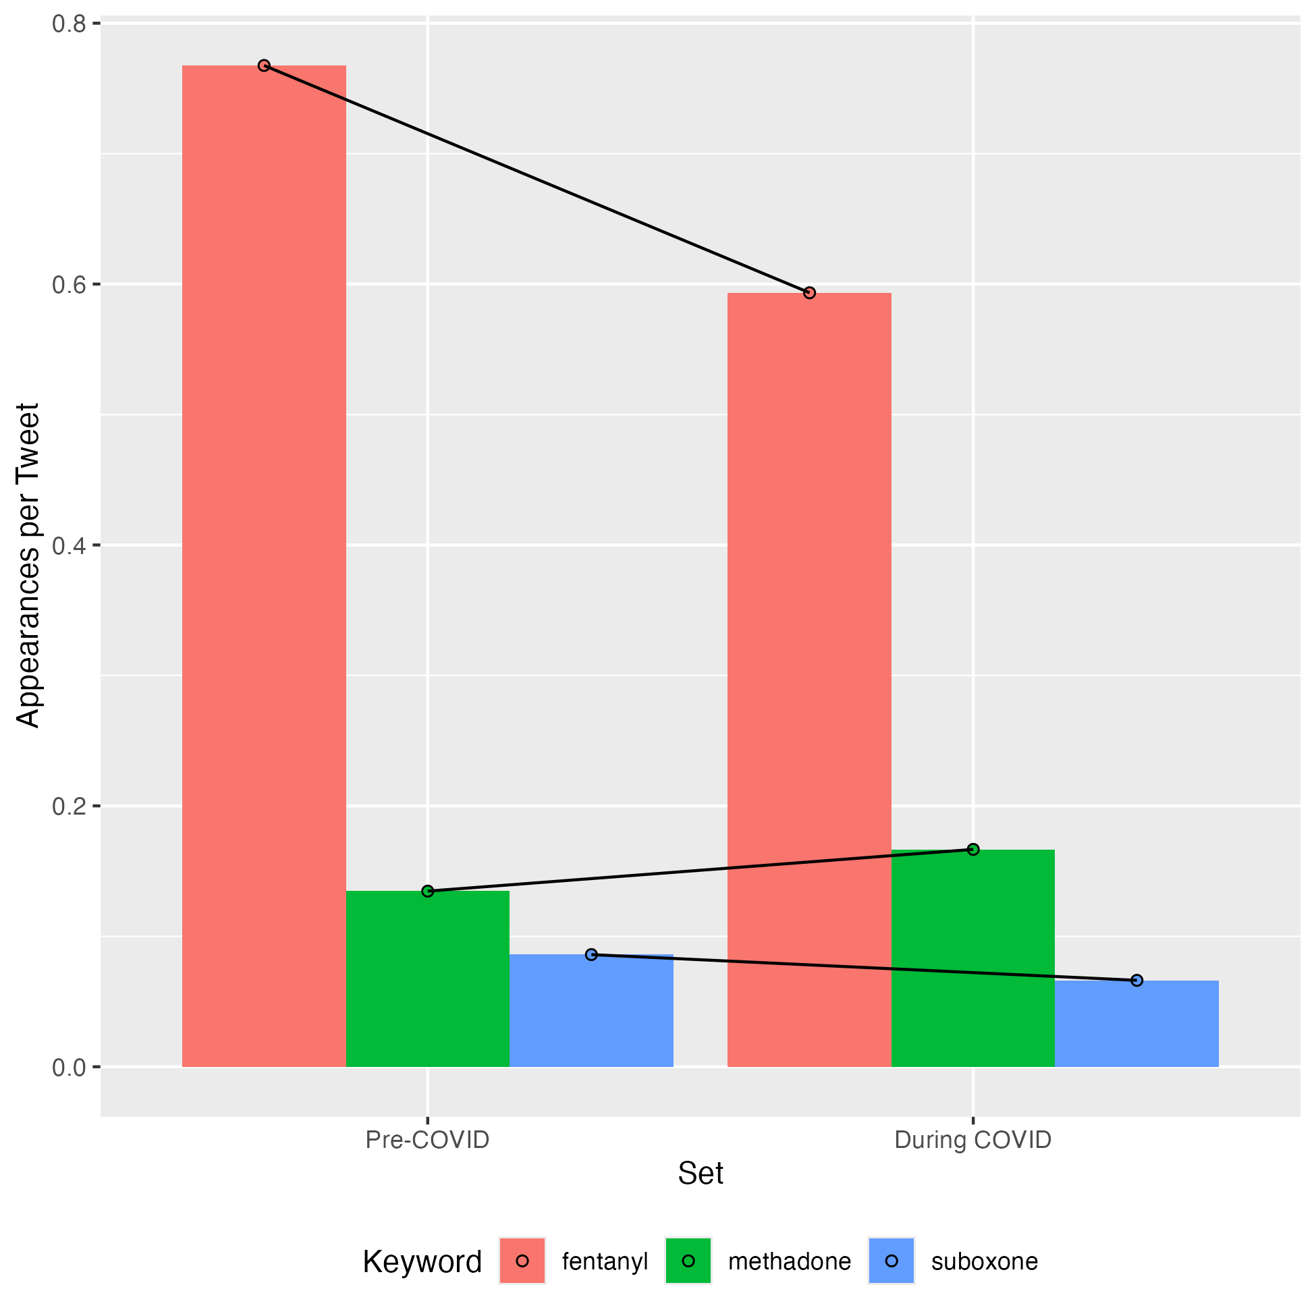

Figure 2
Common terms in Set 1
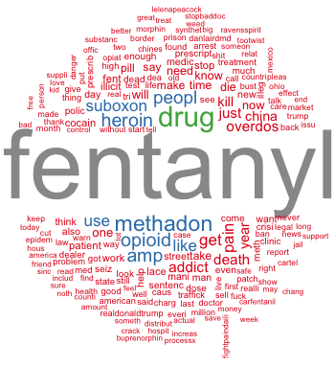

Figure 3
Common terms in Set 2
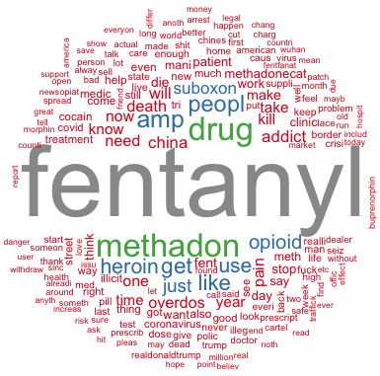

Figure 4
Most common bigrams in Set 1 and Set 2
